TRADE OF
Pipefitting

PHASE 2

Module 2

Thermal Processes

UNIT: 3

Manual Metal Arc Welding

Produced by

In cooperation with subject matter expert:

Finbar Smith

© SOLAS 2014
Table of Contents
Unit Objective 1
Learning Outcome 2
1.0 MMA Welding for Pipefitting 3
1.2 Manual Metal Arc Welding Process 3
2.0 Equipment Used in MMA Welding 5
2.1 MMA Welding Power Supplies 5
2.2 Types of Power Supply for Arc Welding 6
2.3 Polarity Settings for Welding Electrodes 6
2.4 The Advantages and Disadvantages MMA Welding 7
2.5 The Advantages and Disadvantages of AC and DC Welding Plants 7
2.6 MMA Welding Cables 8
2.7 Setting Up a MMA Welding Plant 9
3.0 Hazards and Safety Precautions Associated With MMA Welding 10
3.1 Protection for the Operator 10
3.2 Protection for Others 11
3.3 General Safety Precautions 11
3.4 Safety Precautions While MMA Welding 11
4.0 Welding Techniques 13
4.1 Current Too Low 13
4.2 Current Too High 13
4.3 Correct Current 14
4.4 Arc Length 14
4.5 Speed of Travel 15
5.0 MMA Welding Electrodes 16
5.1 Welding Electrodes 16
5.2 Functions of the Electrode Coating 16
5.3 Classification System for Welding Electrodes 17
5.4 Care of Electrodes 18
6.0 Identify Weld Defects and Their Causes 19
6.1 Weld Defects and their Causes 19
6.2 Control of Distortion 22
7.0 Weld Symbols and Terminology Used On Drawings 24
7.1 Weld Symbols on Drawings 24
7.2 Welding Standards Drawing Notation 25
7.3 Explanation for Standard Weld Symbols 26
7.4 Intermittent Welds 29
Exercises 30
Additional Resources 30

Unit Objective
There are seven Units in Module 2. Unit 1 focuses on Introduction to Thermal Process and safety, Unit 2; Introduction to Oxy-acetylene welding, Unit 3; Manual Metal Arc welding, Unit 4; Metal Active Gas welding, Unit 5; Tungsten Active Gas welding, Unit 6; Oxy-fuel cutting and Unit 7 Plasma arc cutting.
In this unit you will be introduced to Manual Metal Arc (MMA) welding and the safety precautions required when using MMA equipment.
Module 2
Thermal Processes
Unit 1
Introduction to Thermal Processes and Safety

Unit 2
Introduction to Oxy-Acetylene Welding
Unit 3
Manual Metal Arc Welding
Unit 5
Tungsten Active Gas Shielded Welding
Unit 4
Metal Active Gas Welding
Unit 6
Oxy-Fuel Cutting
Unit 7
Plasma Arc Cutting

Learning Outcome
By the end of this unit each apprentice will be able to:
- Define the MMA welding process and applications in the pipefitting industry
- Identify the different types of Manual Metal Arc (MMA) plant, equipment and their functions
- Set up MMA welding equipment to complete welding exercises
- State the risks and hazards associated with the MMA welding process
- State the safety precautions and Personal Protective Equipment (PPE) applicable to MMA Welding
- Identify electrodes by metric size and coating and interpret classifications according to EN standards
- Identify weld defects and their causes
- Identify weld symbols and terminology used on pipefitting drawings

1.0 MMA Welding for Pipefitting

Key Learning Points
- Identify how the MMA welding process works

1.2 Manual Metal Arc Welding Process
Arc welding processes uses an electrical power supply to create and maintain an electric arc between an electrode and the base material to melt metals at the welding point. They can use either direct (DC) or alternating (AC) current, and consumable or non-consumable electrodes. The welding region is protected by some type of inert or semi-inert gas, known as a shielding gas.
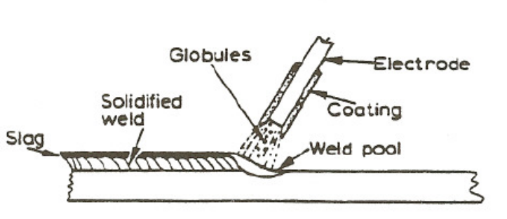
The manual metal arc process occurs when two wires which form part of an electrical circuit are brought together and then pulled slowly apart, an electric spark is produced across their ends. This spark, or arc as it is called, has a temperature of up to 3,600°C. As the arc is confined to a very small area it can melt metal almost instantly. If one of these wires is connected to the job and the other to a wire rod or electrode, as it is usually called, the heat of the arc melts both the metal of the job and the point of the electrode. The molten metal from the electrode mixes with that from the job and forms the weld. It is important to realize that tiny globules of the molten metal from the electrode are forced through the arc (they do not fall by gravity). If this were not so it would be impossible to use this process for overhead welding.
To create the arc for welding, a voltage between 60 and 100 Volts is required to create the arc, but once it has been established, 20–40 Volts is required to maintain it. The following stages occur when creating an arc:
- With the welding plant switched on, and before welding commences, no current passes through the leads and the ammeter reads zero. A voltage has been applied to the circuit, however, and the voltmeter will read the open-circuit or no-load voltage (i.e. between 60 and 100 V).
- When the electrode is brought into contact with the job a large current, called The Short-circuit Current, passes through the leads, and the ammeter will deflect a large amount. While this is happening, however, the voltage drops almost to nothing. The tip of the electrode becomes hot because of the resistance created between it and the job.
- If the electrode is slightly withdrawn an arc is formed between the electrode and the job. The air between the two conducts the welding current. As the arc is formed the voltage rises to between 20 and 40 V and the current falls to the value to which it has been set (i.e. the welding current). The arc is then in the normal welding condition. The heat generated by the arc melts both the work piece and the electrode, and metal is deposited in the weld pool. During the depositing of the weld metal, variations in both the voltage and current of the arc can occur and the welding plant must be capable of coping with these changes.

2.0 Equipment Used in MMA Welding

Key Learning Points
- Identify the equipment used in manual metal arc welding
The principal equipment used in manual metal-arc welding includes:
- Welding power source
- Cables
- Electrode holder
- Earth clamp.
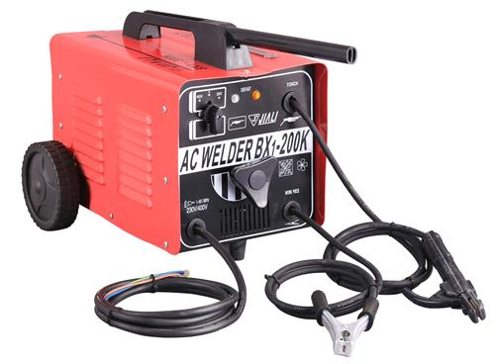
Manual metal arc power source and welding leads

2.1 MMA Welding Power Supplies
There are two types of welding power source used to supply current for metal-arc welding.
- Alternating Current (AC) type.
- Direct current (DC) type.
The AC power source
This power source takes its power directly from the main electricity supply. It uses a transformer to supply the correct voltage to suit the welding conditions. A special device in the transformer allows the current in the secondary coil to be adjusted. The primary coil is connected to the electricity power supply and the secondary coil is connected to the earth clamp and the electrode holder.
The DC power source
There are two types of DC welding plant in use:
- DC generator
- Transformer-rectifier.
The DC generator uses a motor (electric, petrol or diesel powered) to generate electricity. The generator provides DC current for the arc.
A Transformer-rectifier is basically a transformer with an electrical device for changing the alternating current into a direct current output. This device is known as a rectifier. The transformer-rectifier has the advantage that it can be made to supply AC or DC.

2.2 Types of Power Supply for Arc Welding
To supply the electrical energy necessary for arc welding processes, a number of different power supplies can be used. The most common classification is constant current power supplies and constant voltage power supplies. In arc welding, the voltage is directly related to the length of the arc, and the current is related to the amount of heat input. Constant current power supplies are most often used for manual welding processes such as gas tungsten arc welding and shielded metal arc welding, because they maintain a relatively constant current even as the voltage varies. This is important because in manual welding, it can be difficult to hold the electrode perfectly steady, and as a result, the arc length and thus voltage tend to fluctuate. Constant voltage power supplies hold the voltage constant and vary the current, and as a result, are most often used for automated welding processes such as gas metal arc welding, flux cored arc welding, and submerged arc welding. In these processes, arc length is kept constant, since any fluctuation in the distance between the wire and the base material is quickly rectified by a large change in current. For example, if the wire and the base material get too close, the current will rapidly increase, which in turn causes the heat to increase and the tip of the wire to melt, returning it to its original separation distance.

2.3 Polarity Settings for Welding Electrodes
The type of current used in arc welding also plays an important role in welding. Consumable electrode processes such as shielded metal arc welding and gas metal arc welding generally use direct current, but the electrode can be charged either positively or negatively. In welding, the positively charged anode will have a greater heat concentration, and as a result, changing the polarity of the electrode has an impact on weld properties. If the electrode is positively charged, it will melt more quickly, increasing weld penetration and welding speed. Alternatively, a negatively charged electrode results in more shallow welds. Non-consumable electrode processes, such as gas tungsten arc welding, can use either type of direct current, as well as alternating current. However, with direct current, because the electrode only creates the arc and does not provide filler material, a positively charged electrode causes shallow welds, while a negatively charged electrode makes deeper welds. Alternating current rapidly moves between these two, resulting in medium-penetration welds. One disadvantage of AC, the fact that the arc must be re-ignited after every zero crossing, has been addressed with the invention of special power units that produce a square wave pattern instead of the normal sine wave, making rapid zero crossings possible and minimising the effects of the problem.

2.4 The Advantages and Disadvantages MMA Welding

The Advantages of MMA Welding
- Flux Shielded Manual Metal Arc Welding is the simplest of all the arc welding processes.
- The equipment can be portable and the cost is fairly low.
- This process finds innumerable applications, because of the availability of a wide variety of electrodes.
- A wide range of metals and their alloys can be welded.
- Welding can be carried out in any position with highest weld quality.
- The process can be very well employed for hard facing and metal deposition to reclaim parts or to develop other characteristics like wear resistance etc.
- Joints (e.g. between nozzles and shell in a pressure vessel) which because of their position are difficult to be welded by automatic welding machines are easily accomplished by flux shielded metal arc welding.

The Disadvantages of MMA Welding
- Because of the limited length of each electrode and brittle flux coating, it is difficult to automate the process.
- In welding long joints (e.g., in pressure vessels), as one electrode finishes, the weld is to be progressed with the next electrode. Unless properly cared, a defect (like slag inclusion or insufficient penetration) may occur at the place where welding is restarted with the new electrode.
- The process uses stick electrodes and thus it is slower as compared to MIG welding.

2.5 The Advantages and Disadvantages of AC and DC Welding Plants

The Advantage of A. C. Welding Plants
- They are cheaper to buy than D.C. Sets. The initial cost is approx. V of that required for a D.C. set of equivalent rating.
- Little or no maintenance cost, this is because there are no moving parts in an A.C. Transformer.
- There is no “Arc Blow” as with D.C.

The Disadvantages of A. C. Welding Plants
- Non ferrous electrodes are not so well deposited.
- The electric shock hazard is more pronounced with A.C. than with D.C.

The Advantages of D.C. Welding
- They can be used to deposit both ferrous and non-ferrous electrodes.
- Smoother welding giving an advantage when welding thin sheet metal.
- Safer to use in damp conditions where risk of electric shock is greater i.e. boiler work etc.
- Petrol or diesel sets can be used in remote areas where there is no mains supply. Site work etc.

Disadvantages with D.C. Welding
- More expensive to purchase than A.C. Sets.
- Perodic maintenance of the plant is necessary because of the moving parts.
- Troubles from “Arc Blow”.

Arc Blow
“Arc Blow” is encountered with D.C welding equipment. The arc is forced away from the weld point notably when welding in corners. The conductors carrying the current namely the welding lead from the set, and the return lead from the work piece are carrying current in opposite direction so that a repulsive magnetic force is set up which effects the D.C. Welding Arc.
This conditions occurs most when using currents above 200 or below 40 amps. The best method of connections are:
- Weld away from the earth connection.
- Change the position of the earth wire on the work.
- Wrap the welding cable a few turns around the work, if possible on girders etc.
- Change the position of the work on the table if working at a bench.

2.6 MMA Welding Cables
The purpose of the cables is to carry the current required for the arc. One cable ends at the earth clamp. The other goes to the electrode holder. It is important that the cables are not too small in diameter. Small cables may have too high a resistance and may overheat during the welding operation. Most cables contain many strands of fine copper wire. This enables them to carry the electric current and it makes them very flexible.

The Electrode Holder
The electrode holder is an electrically insulated clamping device which holds the electrode. It is connected to one of the cables coming from the welding plant. The current passes from the cable through the electrode holder to the electrode.

The Earth Clamp
This is connected to the other cable coming from the power plant. It is secured to the work by means of a screw clamp or a strong spring-operated clip.

2.7 Setting Up a MMA Welding Plant
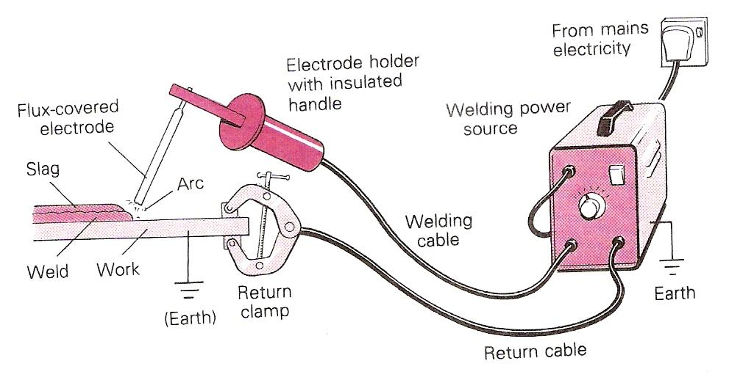
The work is connected to the source of electrical supply (welding set). The electrode holder, held by the operator, is connected to the same source. The electric arc completes the circuit.
Set-Up for Manual Metal Arc Welding
The arc will not start until the electrode touches the work. This completes the circuit. When the electrode is lifted away slightly, and a gap appears once more, electricity passes across the gap using the lined-up atoms of (ionised) air as a conductor. The arc is stopped, or broken, by moving the electrode further away. Intense heat is developed; temperatures in manual metal arc welding measure up to 6000°C. The heat at the upper end of the arc melts the consumable electrode, while the heat at the lower end of the arc melts the parent metal (the metal being welded).

3.0 Hazards and Safety Precautions Associated With MMA Welding

Key Learning Points
- Identify specific hazards pertinent to MMA welding
- Identify how these hazards are eliminated or minimised
- Identify how hazards towards others are minimised
- Identify safety precautions to be observed while MMA welding

3.1 Protection for the Operator
When welding the operator should observe all the general safe working procedures required for thermal processes, some specific to MMA welding are as follows:
- Ensure that there are no areas of exposed skin as ultra-violet rays from the weld arc will burn the skin.
- Only wear regulation inflammable overalls as arc-welding produces large amounts of hot sparks which will set flammable clothing alight. Suitable head cover should be worn to protect from sparks if welding overhead.
- Arc-welding produces heat, glare, sparks, ultra-violet & infra-red rays and harmful fumes. Welding gauntlets must be worn at all times.
- Face masks are designed to deflect fumes and should therefore be held close to the face.
- Ensure that the correct shade 11 EW filters are fitted in the face mask for manual metal arc welding
- Gas welding goggles do not afford protection for the face against the light intensity or the radiation and must not be used.
- Always wear protective goggles when chipping slag.
- Ensure adequate ventilation at source, when welding inside buildings. This is a requirement by law and is there to protect the operator and others. Welding of some materials (i.e. galvanised steel) produces highly toxic fumes
- Check your surroundings, when you are welding behind a dark face mask you will be unaware of what is happening around you. Clear the surroundings of flammable material and ensure there is a fire extinguisher available.
- Check all welding cables for any loose connections that would cause arching thereby creating a hazard. Ensure your surroundings are dry and where possible stand on a timber “duck-board”.
- When welding in confined spaces please refer to separate training required for entering and working in confined spaces as this requires specialist knowledge, training and equipment.
- Do not wells over Paint/Oils/Grease/Solvents as striking the arc will prove difficult and toxic fumes will be produced

3.2 Protection for Others
- Before welding, ensure others are protected from the arc rays by erecting screens. Ultra-violet rays cause the condition known as “arc-eye” which is really conjunctivitis. If affected, the eyes should be thoroughly washed with an eye bath. If the condition persists, medical advice should be sought.
- An individual who has been electrocuted could still be in contact with the power source and therefore should be removed with the use of non-conducting material to protect the rescuer.
- Onlookers to the welding process must be informed of the need to wear protective clothing and PPE.

3.3 General Safety Precautions
- Ensure a suitable Fire Extinguisher and fire blanket are readily available and easily accessible in the event of a small fire. Fire blankets may be used to protect small surrounding areas from sparks when completing tie-in or local welds.
- Ensure work area is tidy and all combustible/ flammable materials are removed from the work area to ensure that they are not ignited by excessive heat or stray sparks.
- Ensure adequate clear access is available to the work area in the event of accident or injury. Exits must be kept be free of obstacles.
- Ensure that proper precautions are observed when handling hot materials and that they are not left un-attended for un-suspecting passer-bys to touch.

3.4 Safety Precautions While MMA Welding
- Have full control of the torch/gun and hold it steady. Concentrate on watching the welding operation.
- Support the flexible hose assembly so that drag on the torch/gun is reduced.
- Hold the torch/gun with just sufficient grip at the point of balance to give control. Otherwise it will cause muscle fatigue. Position yourself to avoid over-balancing.
- Warn any bystanders when about to strike the arc.
- Ensure that any portable screens required are in position.
- Ensure protection from radiation reflected from bright surfaces. Screen or temporarily cover polished surfaces in the vicinity.
- Keep the welding screen in front of the eyes until the arc is broken.
- Follow closing down procedure at the end of the work period or when there is a long interruption.
Please refer to your instructor for site specific safety requirements before carrying out any welding procedures.
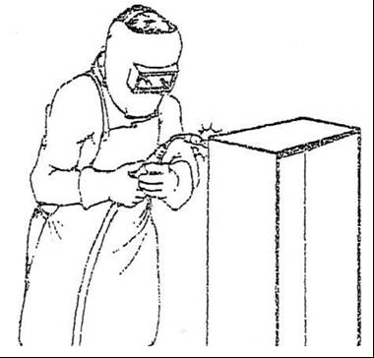
Safety Precautions

4.0 Welding Techniques

Key Learning Points
- Identify the basic parameters which effect quality of the weld bead
- Identify how these parameters can be adjusted to achieve the desired results.

4.1 Current Too Low
If the current value is too low the resulting weld has poor penetration, due to the lack of heating to create complete fusion. The weld filler metal tends to heap up on the surface of the plate without fusing to it and the arc has an unsteady sputtering sound.
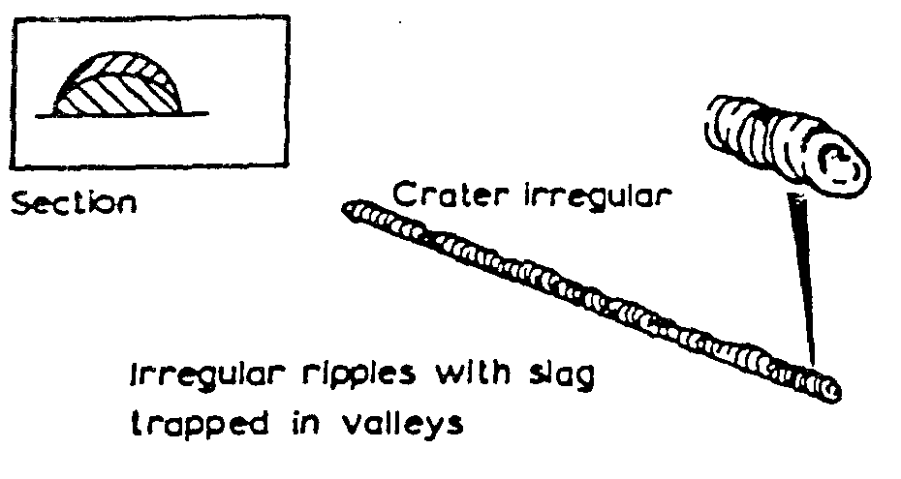
Current too low

4.2 Current Too High
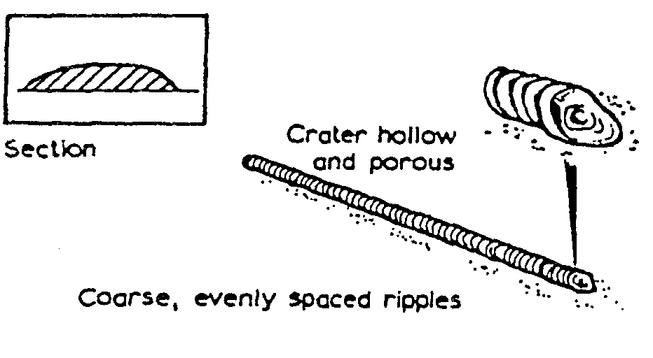
When the current value used is too high the electrode becomes red hot and a large amount of spatter takes place. This can result in blowholes being formed in the plate, excessive penetration resulting in weld metal beads on the underside of the plate, undercut along the edge of the weld and excessive oxidation and slag which is hard to remove. The arc has a fierce crackling sound.
Current too high

4.3 Correct Current
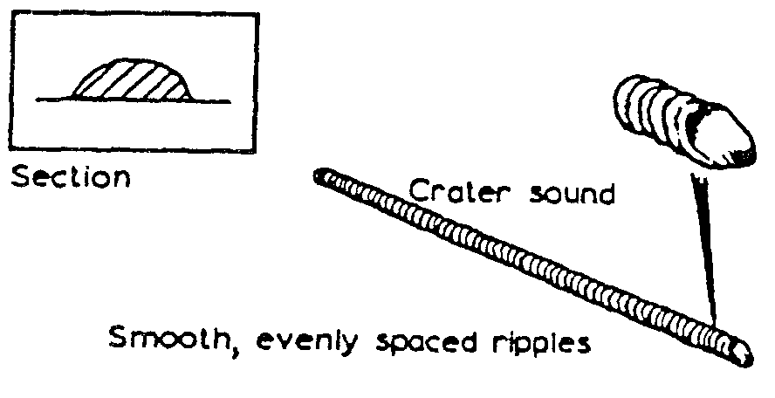
With the correct current the arc has a steady crackling sound. The weld formed has good penetration and is easily controlled.
Correct current

4.4 Arc Length
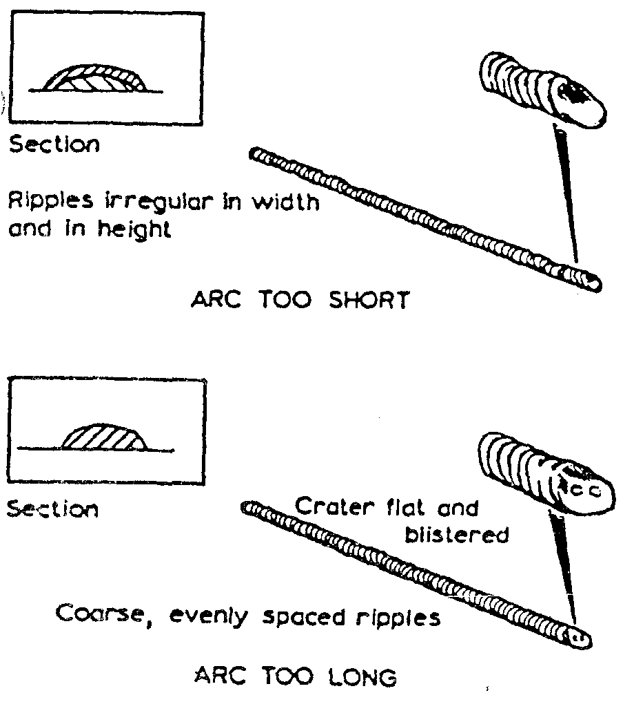
The arc length is the distance between the tip of the electrode and the surface of the weld pool. It should be approximately equal to the diameter of the wire core of the electrode being used. When this distance is correct the electrode metal is deposited in a steady stream of metal particles into the weld pool. If the arc length is reduced it becomes difficult to maintain the arc, due to the increase in welding current that takes place, and it can result in the electrode becoming welded to the weld pool. Also, if the arc length is increased the welding current is reduced, resulting in a poor weld being produced, and the protective gas shield produced from the electrode surrounding the weld pool cannot efficiently prohibit the formation of oxides, etc., in the weld.
Arc length

4.5 Speed of Travel

Too Fast
A fast rate of travel results in a thin deposit of the filler metal and can result in insufficient fusion of the filler metal with the base metal. The surface of the weld has elongated ripples and a porous crater.
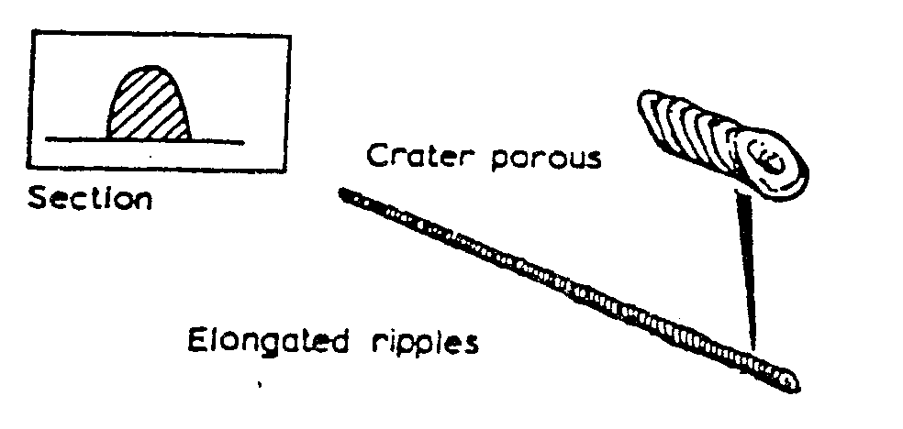
Speed of travel – too fast

Too Slow
Too slow a rate of travel gives a wide thick deposit of the filler and it can allow the slag to flood the weld pool making it difficult to deposit the filler metal. The surface of the weld appears as coarse ripples and has a flat crater.
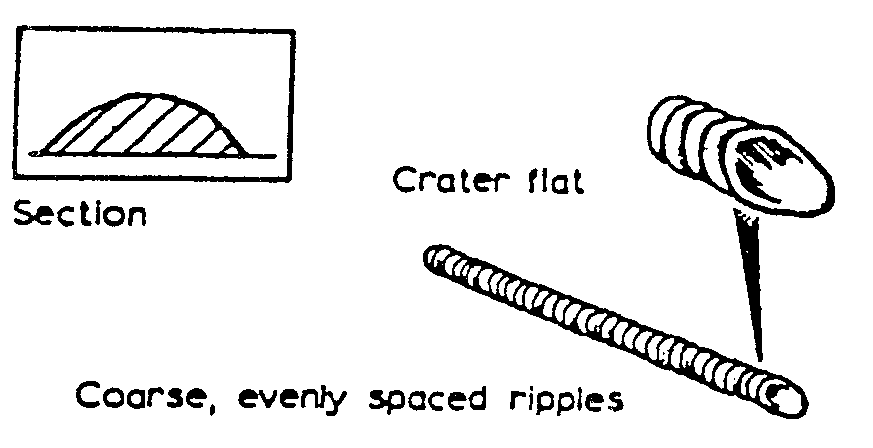
Speed of travel – too slow

5.0 MMA Welding Electrodes

Key Learning Points
- Identify the function of welding electrodes and their coatings
- Identify how electrodes are classified in accordance with AWS standards

5.1 Welding Electrodes
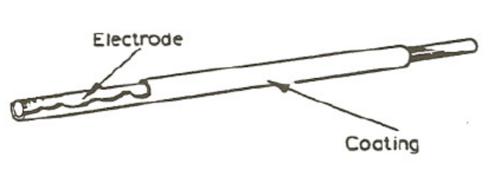
When a piece of metal is heated in the atmosphere it combines with the oxygen and nitrogen to form oxides and nitrides which combine with the metal. If these were allowed to form in the weld it would result in a poor quality, weak and brittle weld. It is therefore necessary to protect the weld area from the air. This can be done either by surrounding the weld area by an inert gas or by the use of suitable fluxes. It is usual, with manual metal arc welding, to use coated electrodes. These electrodes consist of a metal core surrounded by a layer of suitable flux coating.

5.2 Functions of the Electrode Coating
The six main functions of the electrode coating are as follows:
- To act as a flux and remove the impurities from the surfaces being welded.
- To form a protection layer (slag) over the weld, which prevents contact with the air as it starts to cool down. This stops the weld forming brittleness and provides a smoother surface by preventing ripples caused during the welding process.
- It forms a neutral gas atmosphere, which helps to protect the molten weld pool from oxygen and nitrogen in the surrounding air.
- It helps to stabilize the arc, allowing Alternating Current (A.C) to be used.
- It can add certain constituents to the weld by replacing any lost during the welding process.
- It can speed up the welding process by increasing the speed of melting of the metal and the electrode.
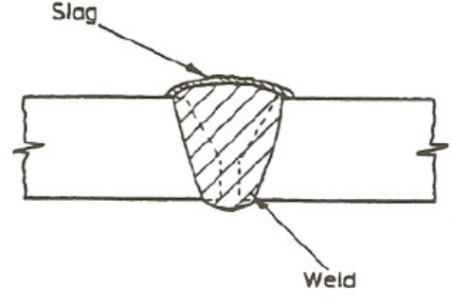
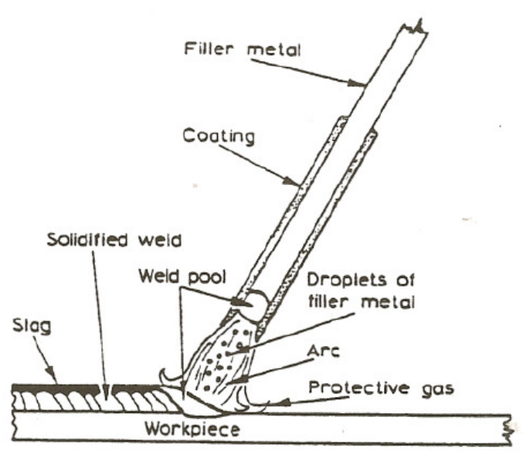

5.3 Classification System for Welding Electrodes
The method of classifying of electrodes in accordance with the American Welding Society (AWS) is based on the use of a Four-digit number, preceded by the letter ‘E’ for ‘Electrode’. The first two digits designate the minimum tensile strength of the weld metal (in 1,000 psi) in the as-welded condition. The third digit indicates the position in which the electrode is capable of making satisfactory welds. The fourth digit indicates the current to be used, and the type of flux coating.
For example, the classification of E6012 electrodes is derived as follows:
E = Metal arc welding electrode.
60 = Weld metal UTS 60,000 psi min.
1 = Usable in all positions.
2 = Rutile type coating: AC or DC negative.
The detail of the classification is shown below:

First and Second Digits
E 60xx As-welded deposit. UTS 60.000 psi min. for E 6010, E 6011,
E 6012, E 6013, E 6020, E 6027 UTS.
E 70xx As-welded deposit, UTS 70.000 psi min. for E 7014, E7015, E7016, E7018, E 7024 and E 7028.

Third and Fourth Digits
The third and fourth digits indicate positional usability and flux coating types e.g.
Exx10 = High cellulose coating, bonded with sodium silicate, deeply penetrating, forceful, spray-type arc, thin, friable slag, all-positional. (Direct Current DC), electrode positive only.
Exx11 = Very similar to Exx10, but bonded with potassium silicate to permit use on AC or DC positive.
Exx12 = High rutile coating, bonded with sodium silicate. Quiet arc, medium penetration, all-positional, on (AC or DC) negative.

5.4 Care of Electrodes
Electrodes for welding mild steel should be kept dry to avoid the possibility of porosity. They should be kept in the packet in which they came to ensure correct identification and to avoid damage to the coating.
They should not be bent to avoid breaking of the coating and subsequent contamination of the weld.

6.0 Identify Weld Defects and Their Causes

Key Learning Points
- Identification of weld defects
- Identify what causes weld defects
- Identify how weld defects can be avoided

6.1 Weld Defects and their Causes

Lack of Penetration
Lack of penetration is the failure of the filler metal to penetrate into the joint. It is caused by:
- Incorrect edge penetration.
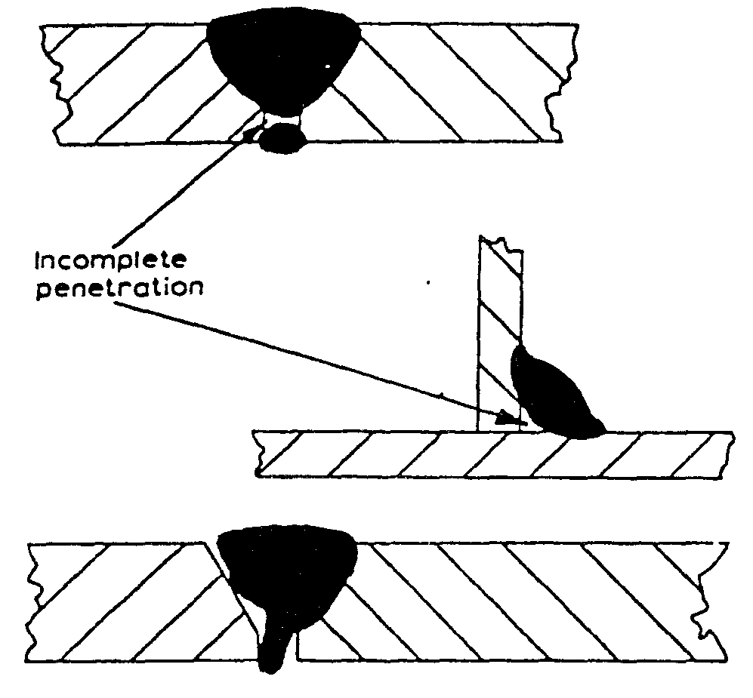
- Incorrect welding technique.
- Inadequate de-slagging.
Lack of penetration

Lack of Fusion
Lack of fusion is the failure of the filler metal to fuse with the parent metal. It is caused by:
- Insufficient heat.
- Too fast a travel.
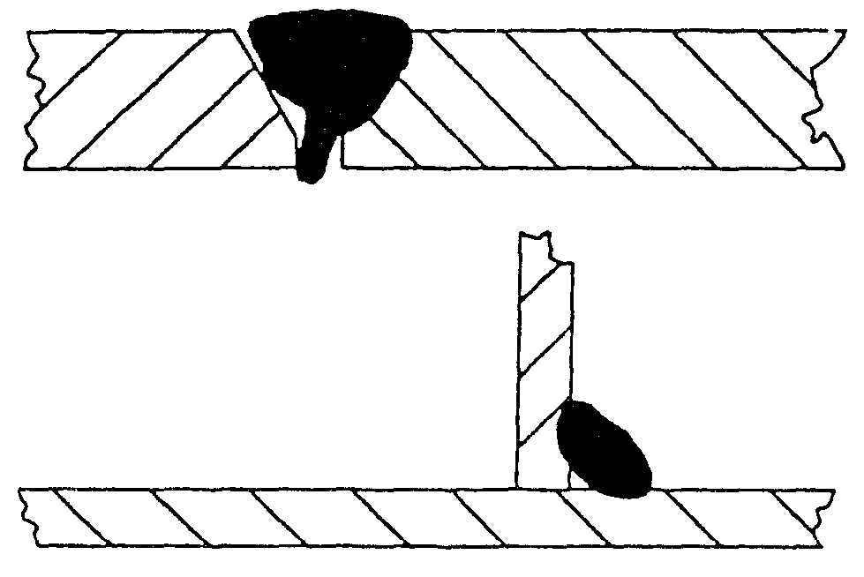
- Incorrect welding technique.
Lack of fusion

Porosity
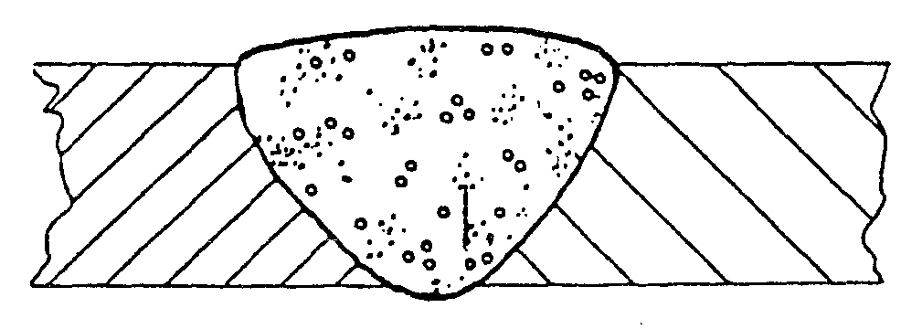
Porosity is a group of small holes throughout the weld metal. It is caused by the trapping of gas during the welding process, due to chemicals in the metal, dampness, or too rapid cooling of the weld.
Porosity

Slag Inclusion
Slag inclusion is the entrapment of slag or other impurities in the weld. It is caused by the slag from previous runs not being cleaned away, or insufficient cleaning and preparation of the base metal before welding commences.
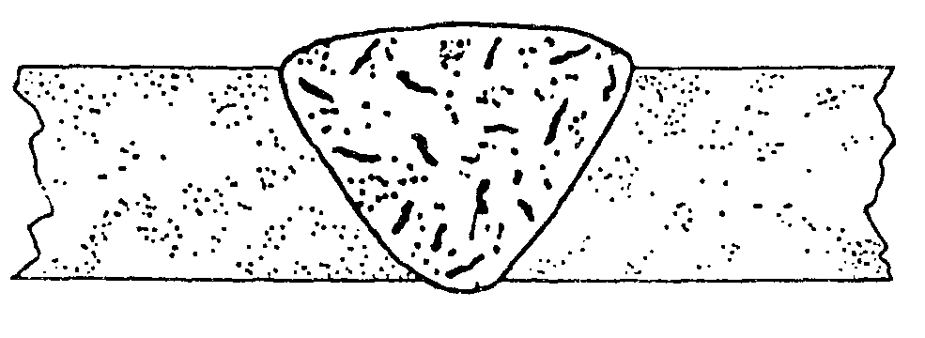
Slag inclusion

Undercut
Undercuts are grooves or slots along the edges of the weld caused by:
- Too fast a travel.
- Too great a heat build-up.
- Bad welding technique.
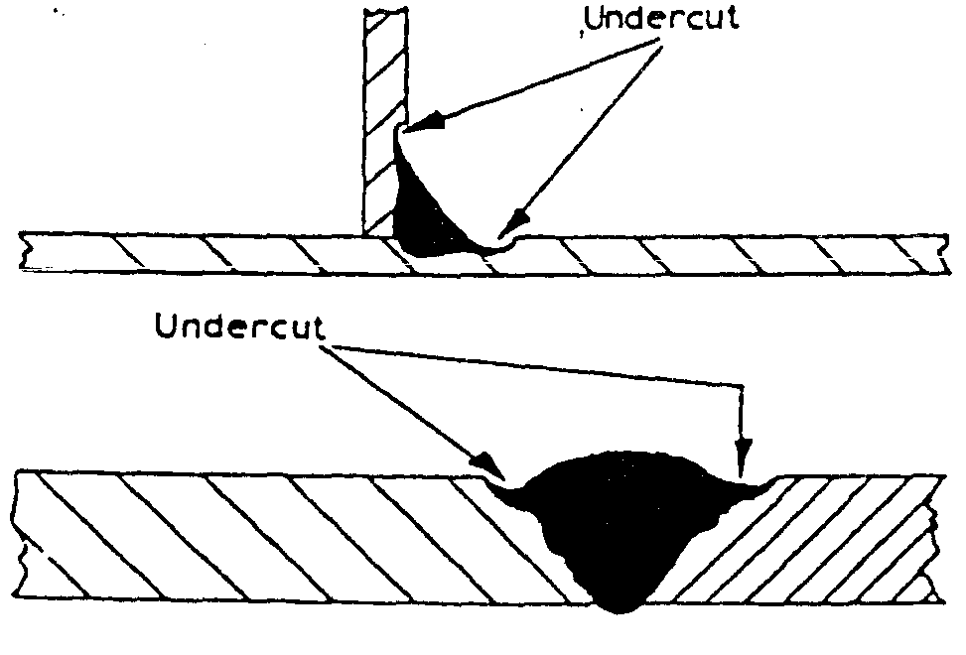
Undercut

Overlays
Overlays consist of metal that has flowed on to the parent metal without fusing with it. The defect is caused by:
- Insufficient heat.
- Contamination of the surface of the parent metal.
- Bad welding technique.
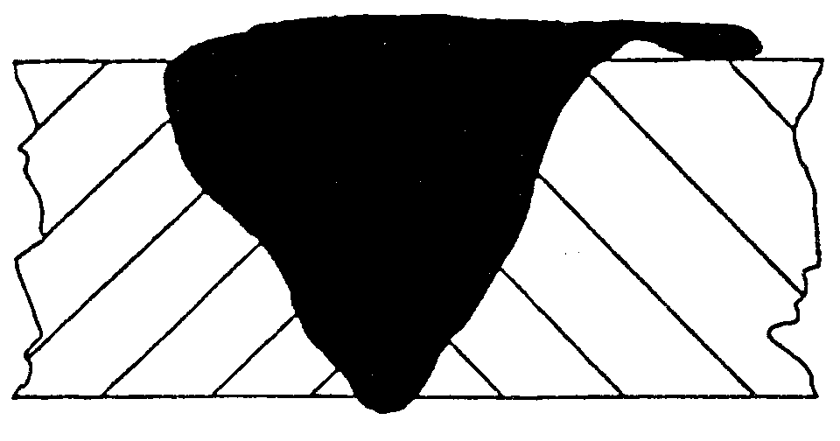
Overlay

Crackling
Cracking is the formation of cracks either in the weld metal or the parent metal. It is caused by:
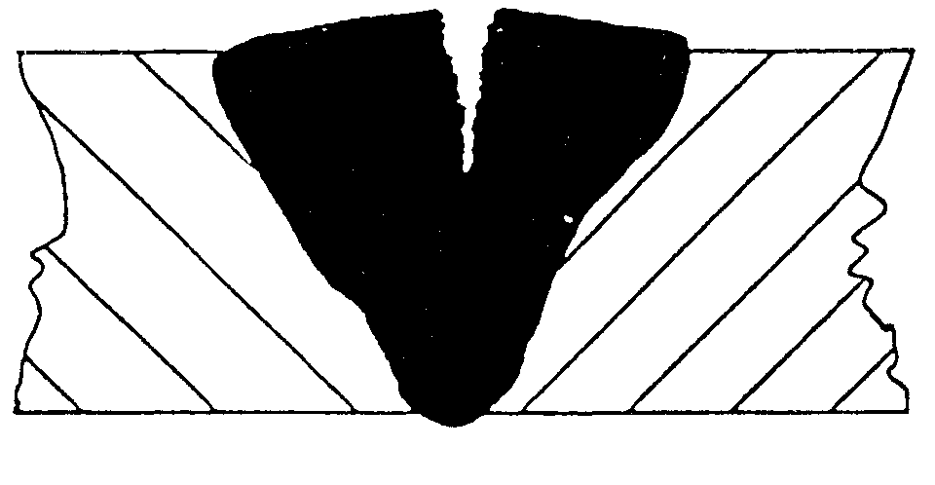
- Bad welding technique.
- Unsuitable parent metals used in the weld.
Crackling

Blowholes
Blowholes are large holes in the weld caused by:
- Gas being trapped, due to moisture.
- Contamination of either the filler or parent metals.
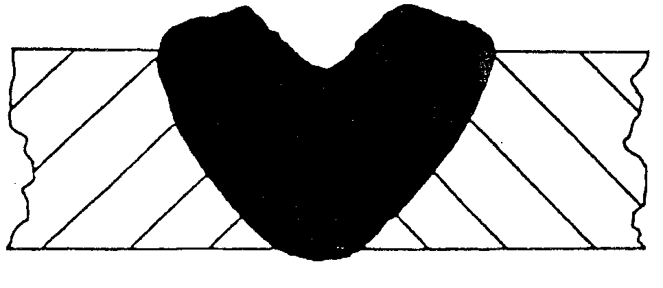
Blowholes

Burn Through
Burn through is the collapse of the weld pool due to:
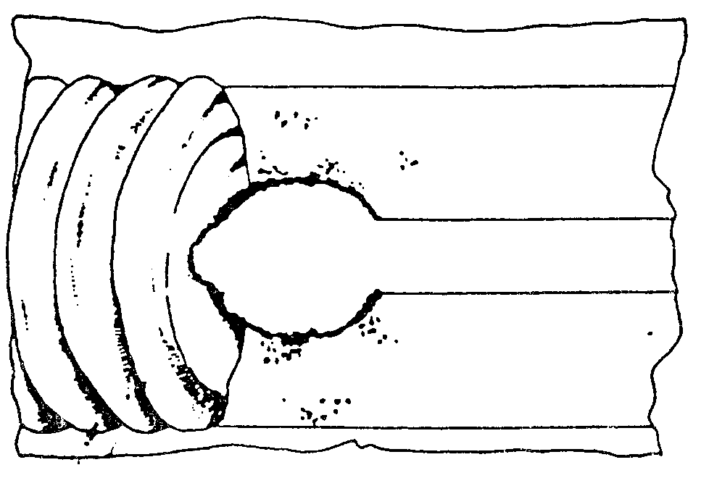
- Poor edge preparation.
- Too great a heat concentration.
Burn Through

Excessive Penetration
Excessive penetration is where the weld metal protrudes through the root of the weld. It is caused by:
- Too big a heat concentration.
- Too slow a travel.
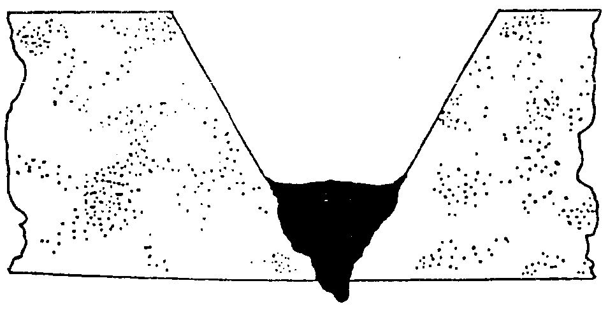
Excessive Penetration

6.2 Control of Distortion

Expansion and Contraction in Welding and Cutting Processes
When a piece of metal is heated it expands and, on cooling down, it contracts. With welding and cutting processes the heating takes place over a localized area of the metal and expansion can only take place in that portion of the metal. The subsequent contraction that takes place on cooling can result in forces causing distortion or, even worse, cracking of the metal. When a weld bead is deposited on the joint between two plates, the molten metal passing through the arc is at a very high temperature. The arc melting the edges of the joint and the filler and base metal fuse together. As the arc moves across the joint the deposited bead starts to cool and considerable contraction forces are set up in the weld area.
As the deposited metal was at a higher temperature than the parent metal it will contract more and also, since its volume is greater, there is a large volume of metal shrinkage. The result is distortion of the joint. The following are several ways of controlling the effect of distortion during welding; presetting; backstepping or stepwelding, jigging, and preheating. They are described and shown below:
Presetting
This entails setting the joint out of alignment prior to welding so that after contraction has taken place the joint is aligned.
Backstepping or Stepwelding
This entails welding the joint in short steps, ensuring that expansion and contraction zones are placed next to one another.
Jigging
This entails holding the metal being welded in a jig, restraining the distortion mechanically.
Preheating
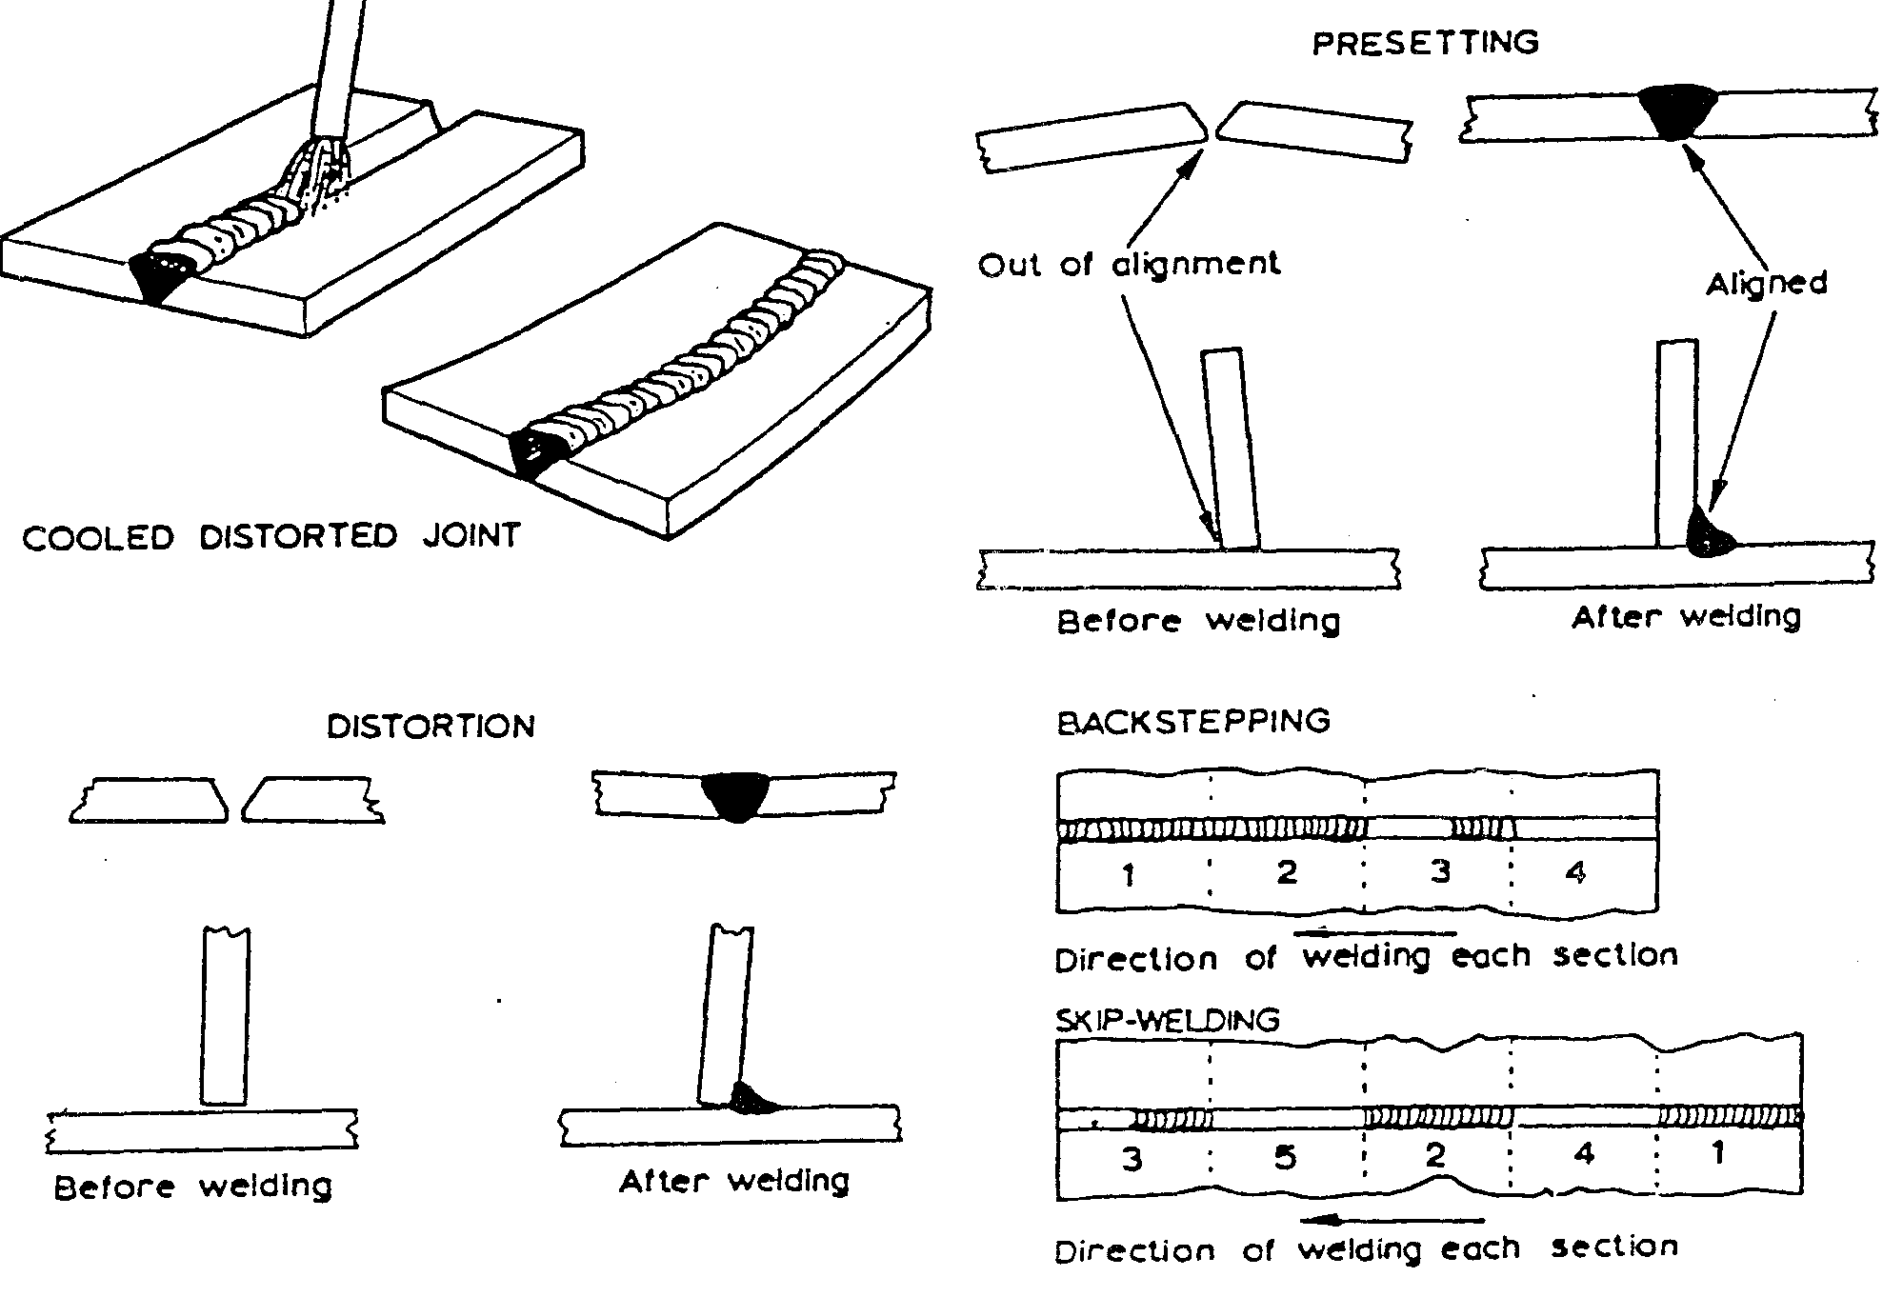
This entails heating the metal to be welded prior to welding, and has the effect of allowing equal contraction to take place in both the weld and parent metal.
Distortion / Presetting / Backstepping / Skip-welding

7.0 Weld Symbols and Terminology Used On Drawings

Key Learning Points
- Identify why weld symbols on drawings are used.
- Identify standard weld symbols and their meaning
- Identify how weld symbols are applied to engineering drawings

7.1 Weld Symbols on Drawings
Engineering drawings are descriptions of manufactured objects in terms of shape. surface, finish and material. In many industries it is customary to draw the shape of the component without indicating how that shape is achieved. The drawing is a description of a requirement produced by the designer for the instruction of the manufacturer. In theory, the manufacturer knows best how to produce an object with the resources he has. In practice, of course. the designer compromises and produces designs which are capable of production by the techniques ,of which he is aware. For example, a round hole can be drilled, bored or punched. and can be finished by reaming, but whichever method is used, the lines on the drawing are the same and whichever method is used, the material is not changed in its characteristics.
A welded joint offers a range of considerations which do not arise in other forms of manufacture. Firstly, there are far more techniques for making a welded joint than in many other manufacturing operations. This means that the designer has far less chance of foreseeing the manufacturer’s methods. Secondly, the properties and integrity of the joint will depend on the manner in which the weld is made Despite this, the designer can still indicate the type of joint he requires. provided that he is prepared to accept that he may not be able to completely define the joint in the earlier stages of a design.
In some industries it is customary for the manufacturer to produce shop drawings which contain details of weld preparations and reference to established welding procedures not shown in detail on the designer’s drawings. The range of British Standard symbols which can be used on a drawing to indicate a weld detail are described here.

7.2 Welding Standards Drawing Notation
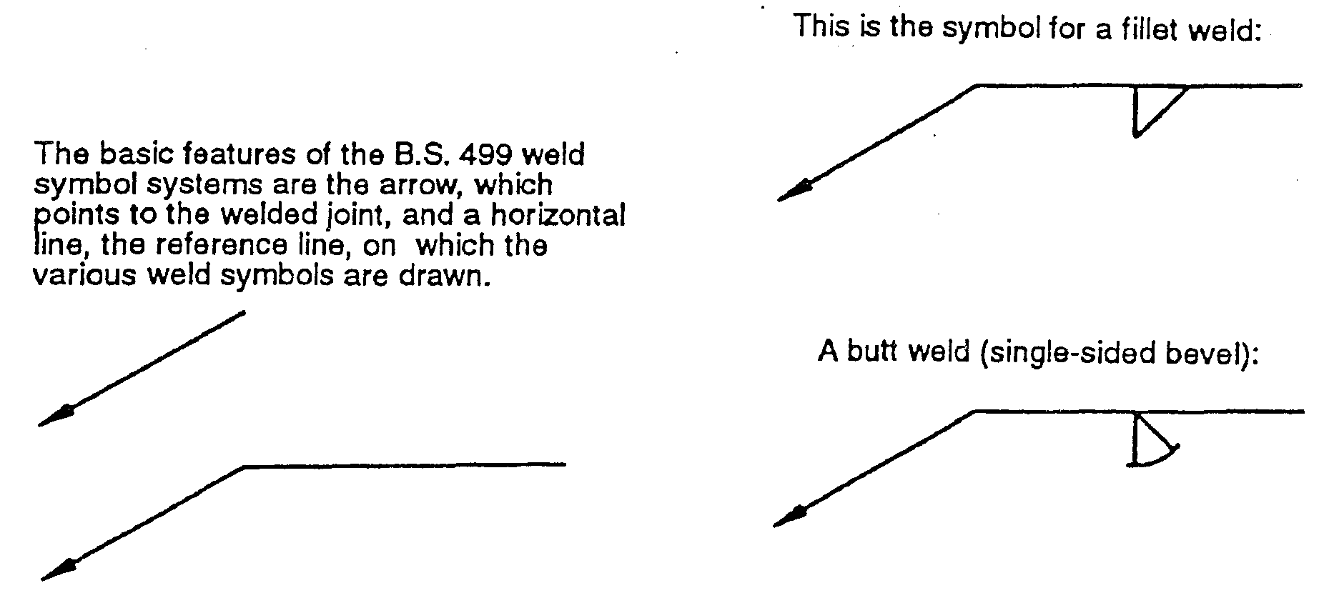
Basic B.S. 499 weld features
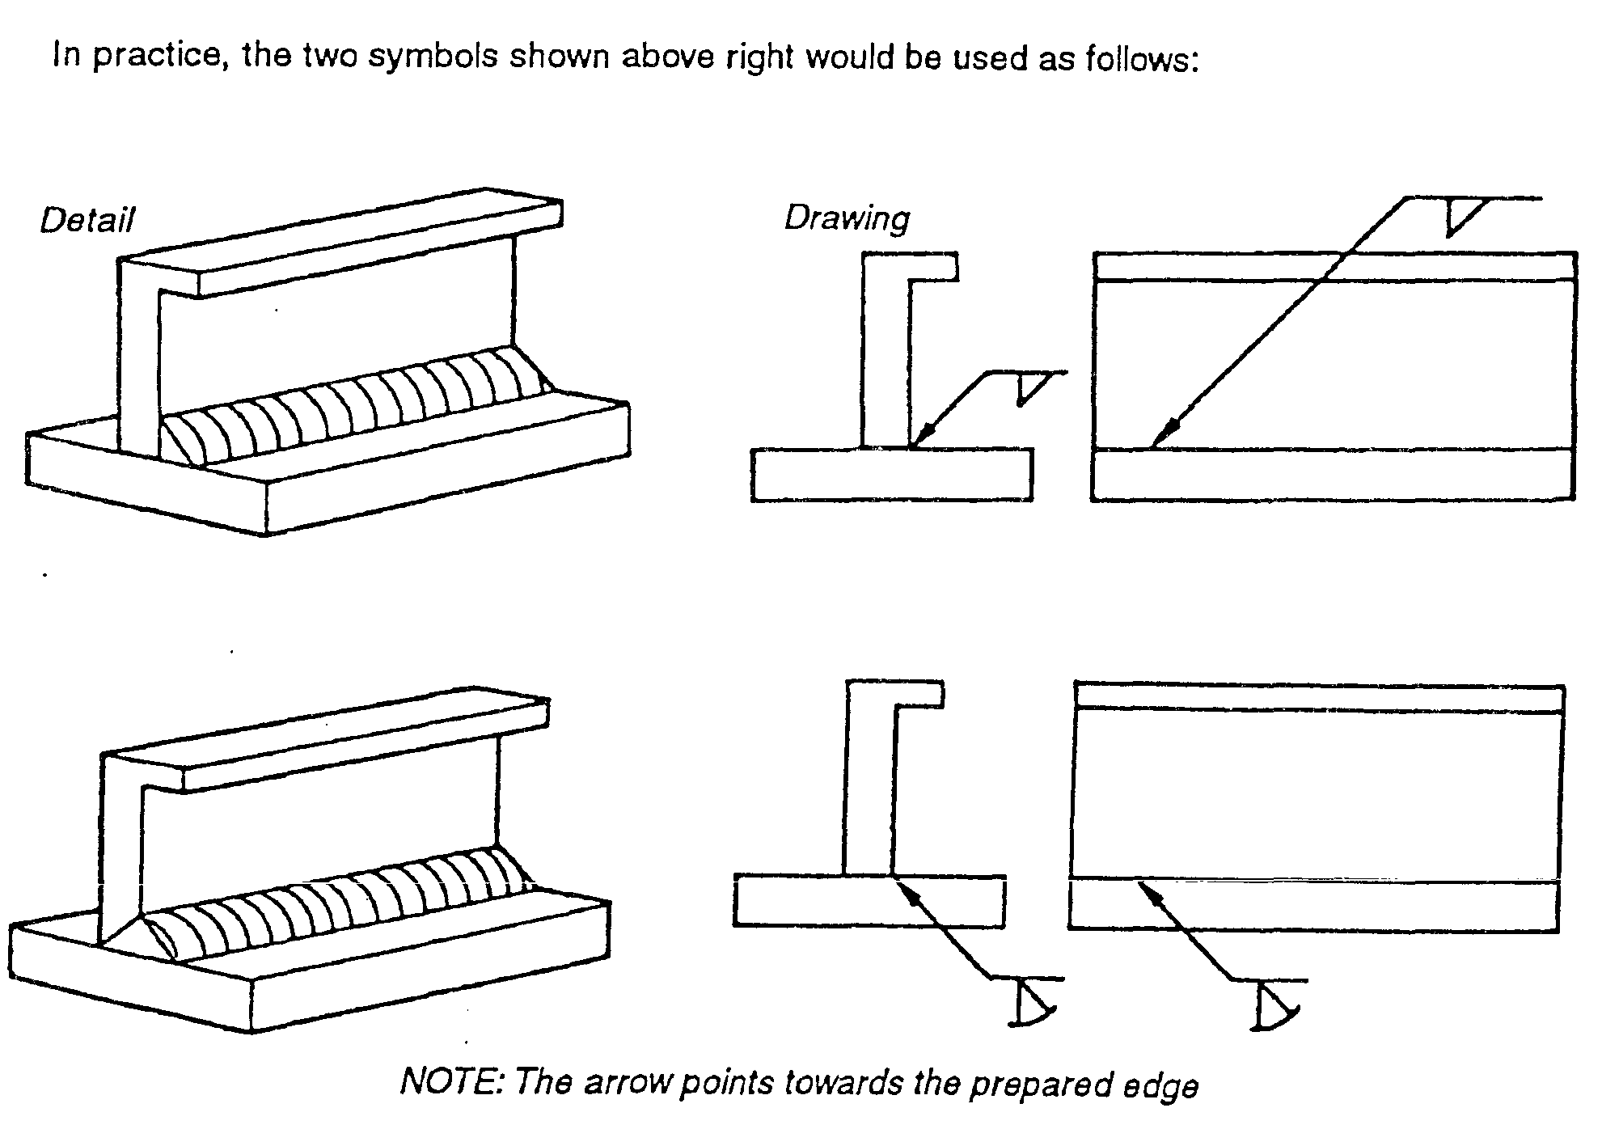
Basic B.S. 499 weld features applied

7.3 Explanation for Standard Weld Symbols
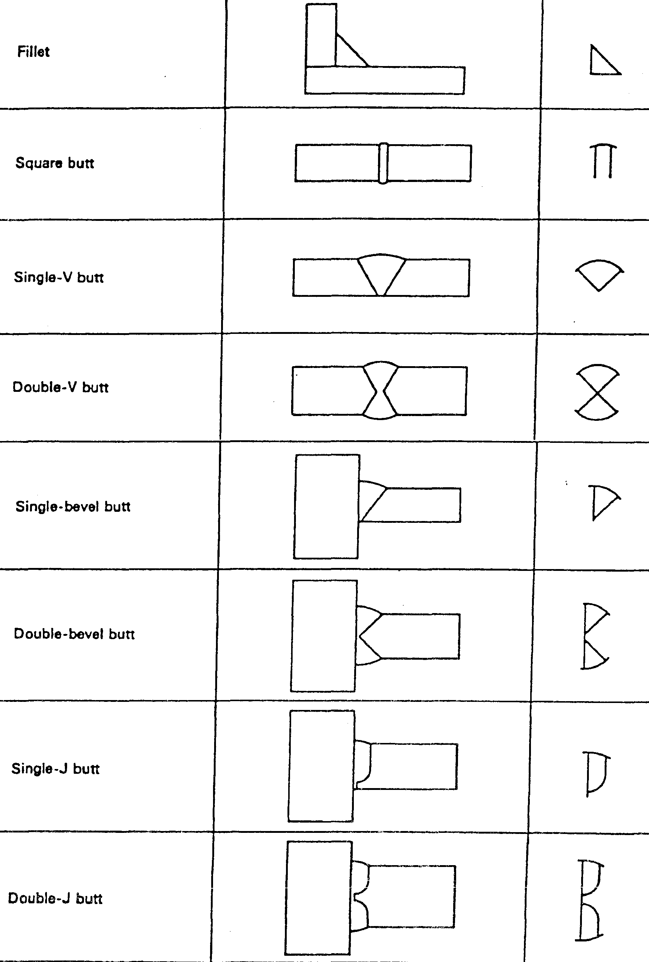
B.S weld symbols 1.
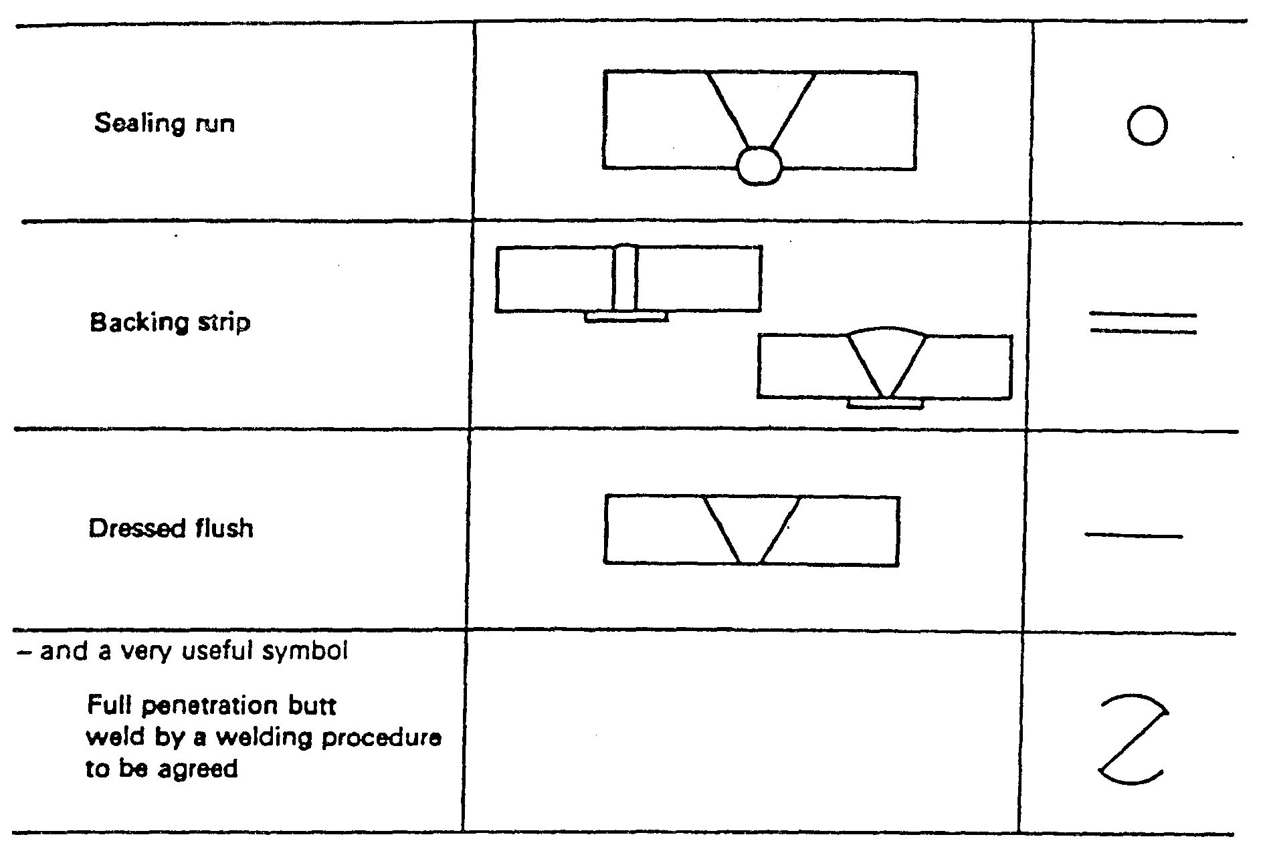
B.S weld symbols 2.

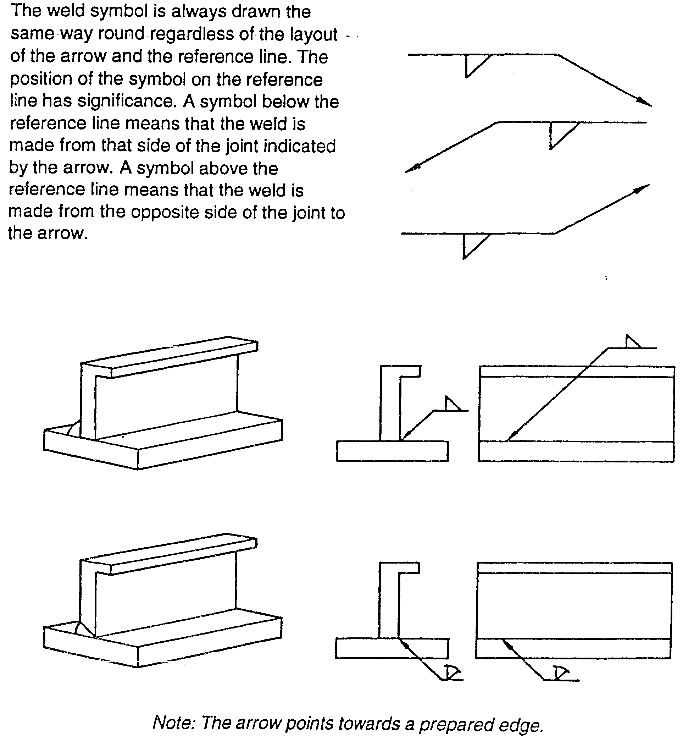
B.S weld symbols example 1
B.S weld symbols example 2.
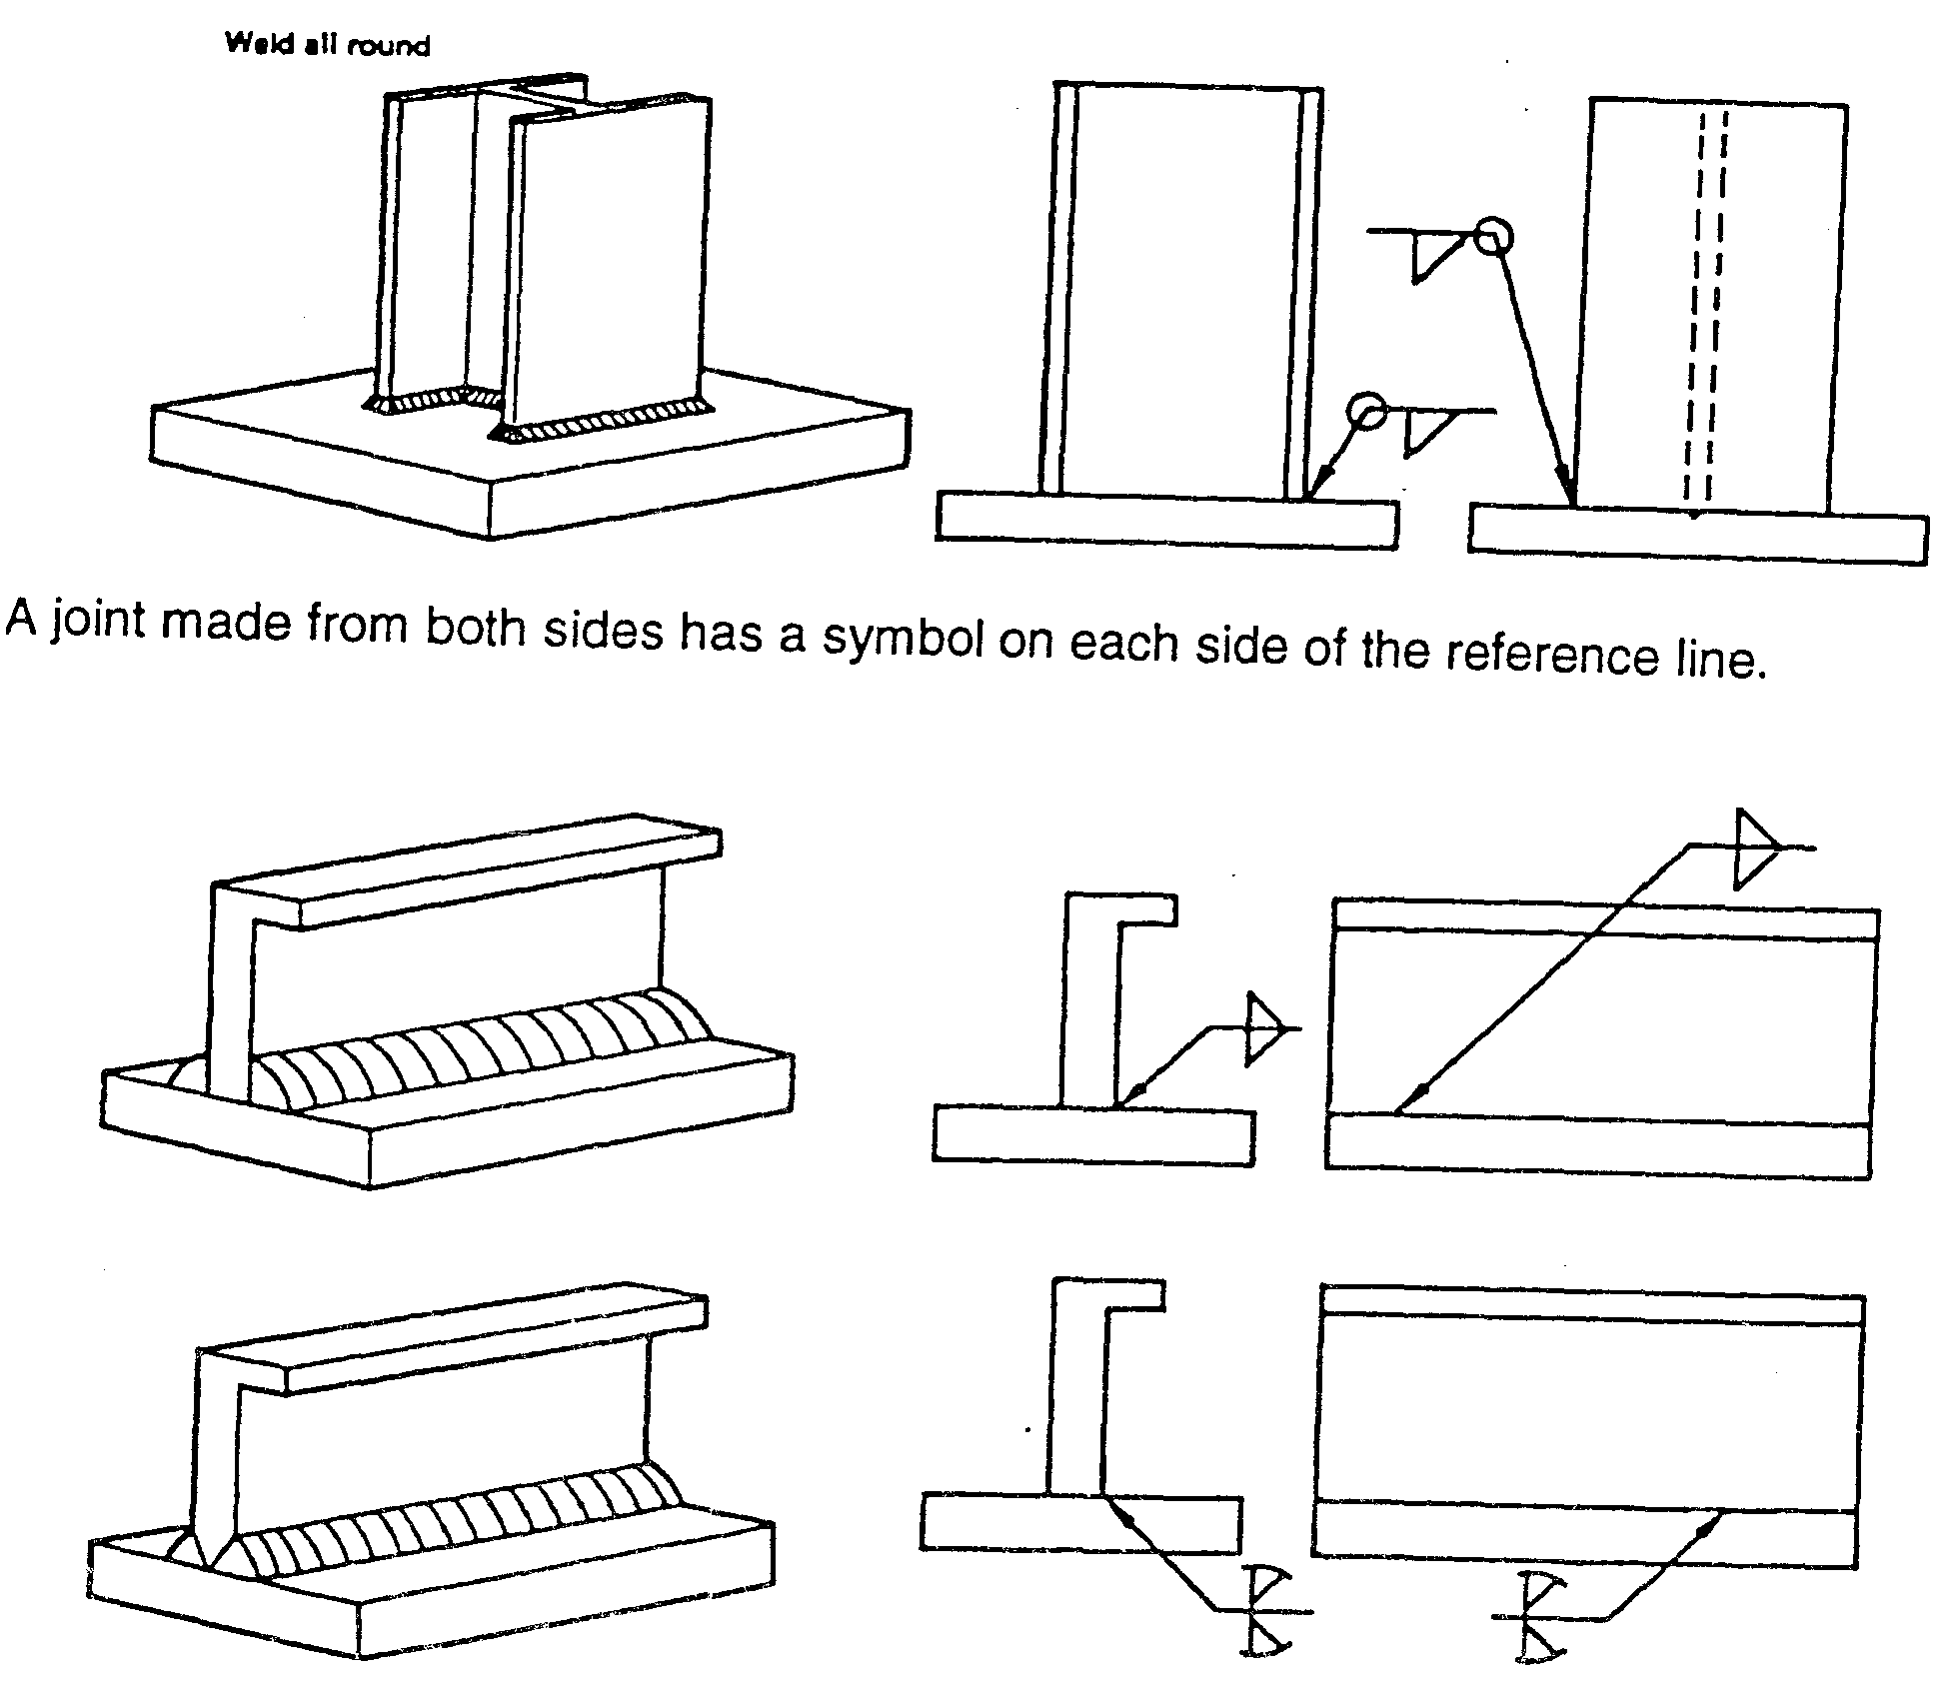
Weld size can be indicated on the symbol. 6 mm fillet weld. The drawing must state whether a throat or leg dimension is quoted.
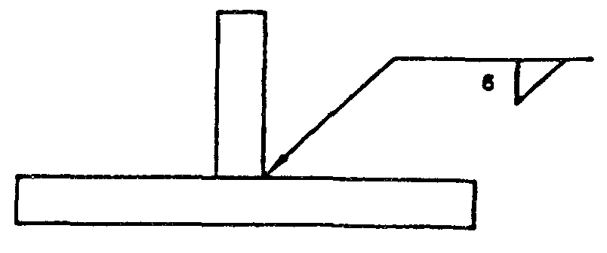
6mm fillet weld
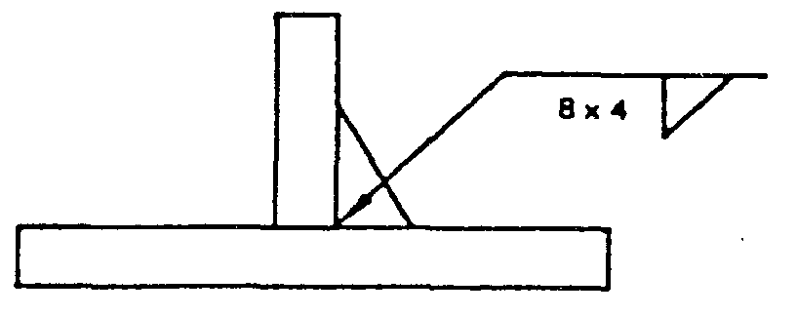
Unequal leg fillet weld. This must be defined by leg length. A diagram of weld ) shape is required here.
Unequal leg fillet weld
A diagram is not required here because the size of the members indicates the weld orientation.
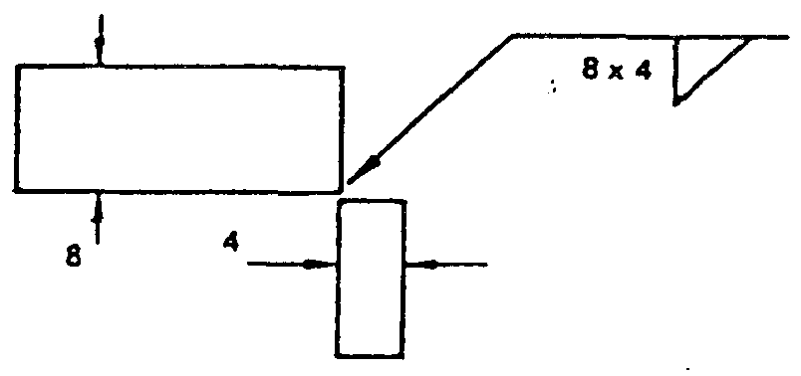
Size of the members

7.4 Intermittent Welds
Information other than weld size may be written to the right of the symbol. The figure in brackets is the space length. 50 before (100) indicates that the weld is at the beginning. (100) 50 would indicate a space first then a weld although such an arrangement would not represent good practice.
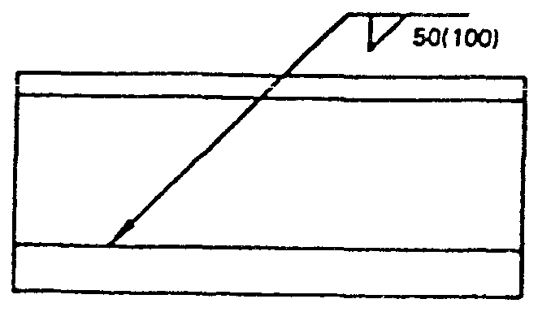
Information on side of the symbol
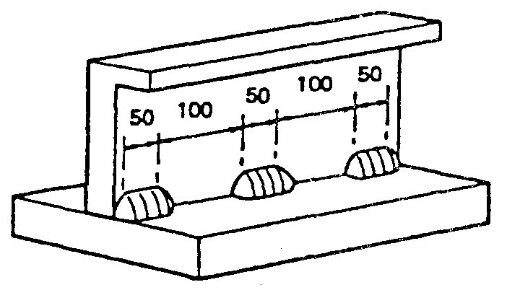
Intermittent welds

Exercises
- Weld lap, tee and butt joints on mild steel plate as shown on Exercise Nos. 2.2.3a and 2.2.3b
- Describe the procedure for preparing mild steel pipe for butt welding and slip-on flange joints

Additional Resources

Title | Author | Ref. Code
The Induction Book, “Code of Behaviour & Health & Safety Guidelines” | SOLAS
Basic Welding and Fabrication | W Kenyon | ISBN 0-582-00536-L
Fundamentals of Fabrication and Welding Engineering | FJM Smith | ISBN 0-582-09799-1
Workshop processes, practices and materials, 3rd edition, Elsevier Science & Technology | Black, Bruce J 2004 | ISBN-13: 9780750660730
New Engineering Technology | Lawrence Smyth & Liam Hennessy | ISBN 086 1674480

Videos:
- Understanding welding fumes
- Welder on Site…Be Aware (Vocam)
- Powered hand tool safety (Vocam)
- Industrial Ergonomics (Vocam)
Available from:
Vocam Ireland
Circle Organisation Ltd
Friar Street, Thurles, Co Tipperary, Ireland
Tel: +353 504 24666

Castleforbes House
Castleforbes Road
Dublin 1

